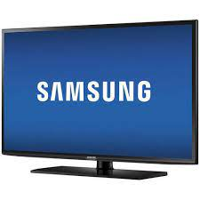

Samsung LED

* Display Features HD
* 1366 X 768 Pixels
* Screen Size 32 Inch
* 2 X HDMI & 1 X USB
* **Rs.36,500**